**Automatic irrigation system**

**Abstract:**

The Automatic Irrigation System is designed to optimize water usage in agriculture by intelligently monitoring soil moisture, water tank levels, and environmental conditions. The system utilizes a soil moisture sensor to detect the soil’s water content and an ultrasonic sensor to measure the water level in the storage tank. A DHT11 sensor continuously monitors temperature and humidity to further enhance irrigation decisions. An Arduino Uno serves as the central controller, processing sensor data and managing system operations, including activating a DC pump when both soil moisture and water levels fall below predefined thresholds. The NodeMCU module uploads real-time sensor data to the Adafruit IoT dashboard, enabling remote monitoring, while a GSM module sends alert messages during abnormal conditions. Additionally, an LCD displays the current status of all sensors locally, and a buzzer provides audible warnings for critical events. The system is powered sustainably using a 9V solar panel and battery setup, ensuring continuous and eco-friendly operation. This integrated approach enhances irrigation efficiency, conserves water, and supports smart farming practices.

**Introduction:**

The Automatic Irrigation System aims to optimize water usage in agriculture by using sensors to monitor soil moisture, water levels, temperature, and humidity. Controlled by an Arduino Uno, the system activates a DC pump only when necessary, conserving water and preventing damage. Real-time data is uploaded to an Adafruit IoT dashboard via NodeMCU, while a GSM module sends alerts during abnormal conditions. The system features an LCD display for local monitoring and is powered sustainably by a 9V solar panel with a battery backup. This smart, automated approach promotes efficient irrigation and supports sustainable farming practices.

**Literature survey:**

**AUTOMATIC PLANT IRRIGATION SYSTEM**

The "Automatic Plant Irrigation System" (APIS) automates irrigation by monitoring soil moisture levels to control a water pump. It reduces human intervention by detecting soil dampness using a soil moisture sensor and activating the pump when irrigation is needed. The system operates in three stages: sensing moisture, determining soil condition, and controlling the motor. Implemented with an LM358 operational amplifier, APIS currently manages irrigation for a small area, aiming to improve farming efficiency and minimize losses from drought or improper watering.

**Automatic irrigation system for plants**

This project aimed to develop an automatic irrigation system for indoor plants, focusing on energy efficiency, system stability, and wireless control. A microcontroller, water pump, and moisture sensor were used to monitor and irrigate a plant over four weeks. The system successfully maintained the plant’s health, and its energy needs were met using solar power, making it a sustainable alternative to battery usage.

**Existing model:**

Current automatic irrigation systems typically use soil moisture sensors and water level sensors to control pumps and prevent damage. Many rely on Arduino for local control, while some include temperature and humidity monitoring. However, few systems integrate real-time IoT monitoring, GSM alerts, and solar-powered operation together. The proposed system aims to fill this gap by combining all these features for a smarter, more efficient, and sustainable irrigation solution.

**Proposed model:**

The proposed automatic irrigation system integrates multiple sensors and technologies to optimize water usage and enhance agricultural efficiency. Soil moisture sensors monitor soil hydration, while ultrasonic sensors track water reservoir levels. A NodeMCU microcontroller uploads sensor data to the Adafruit IoT platform for real-time remote monitoring. A GSM module sends alert messages during abnormal conditions, and a buzzer provides immediate local warnings. The system uses an LCD to display all sensor statuses, ensuring easy onsite monitoring. Powered by a 9V solar panel and battery, the system is energy-efficient and sustainable. When soil moisture or water levels fall below set thresholds, a DC pump is automatically activated to irrigate the crops, ensuring timely water supply and preventing wastage. This model offers a comprehensive, smart, and eco-friendly approach to irrigation management.

**Block diagram:**

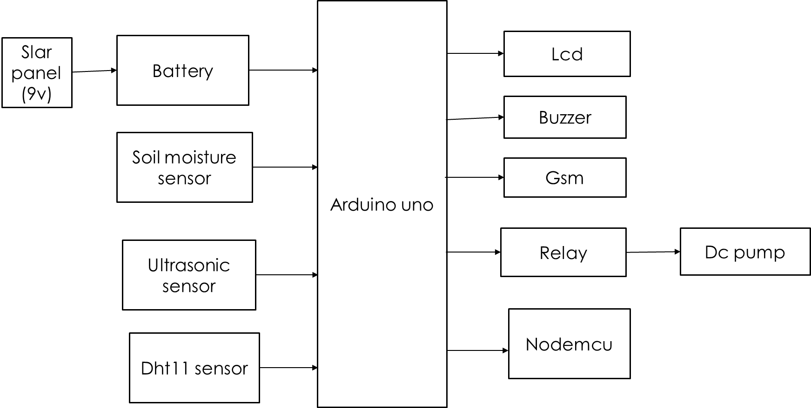

**Hardware components:**

* Arduino uno
* Dht11 sensor
* Soil moisture sensor
* Ultrasonic sensor
* Lcd
* Relay
* Dc pump
* Buzzer
* Gsm
* Nodemcu
* Solar panel(9v)
* Battery(12v)

**Software components:**

* Arduino ide
* Embedded c
* python

**Arduino:**

Arduino Uno is a very valuable addition in the electronics that consists of USB interface, 14 digital I/O pins, 6 analog pins, and Atmega328 microcontroller. It also supports serial communication using Tx and Rx pins.

There are many versions of Arduino boards introduced in the market like Arduino Uno, Arduino Due, Arduino Leonardo, Arduino Mega, however, most common versions are Arduino Uno and Arduino Mega. If you are planning to create a project relating to digital electronics, embedded system, robotics, or IoT, then using Arduino Uno would be the best, easy and most economical option.

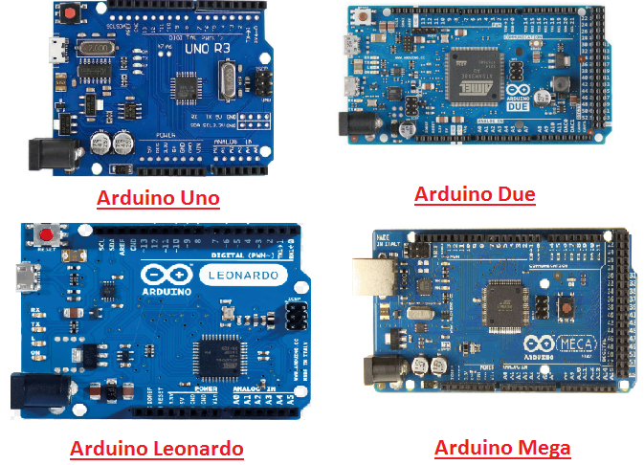

It is an open-source platform, means the boards and software are readily available and anyone can modify and optimize the boards for better functionality.

The software used for Arduino devices is called IDE (Integrated Development Environment) which is free to use and required some basic skills to learn it. It can be programmed using C and C++ language.

Some people get confused between **Microcontroller and Arduino**. While former is just an on system 40 pin chip that comes with a built-in microprocessor and later is a board that comes with the microcontroller in the base of the board, bootloader and allows easy access to input-output pins and makes uploading or burning of the program very easy.

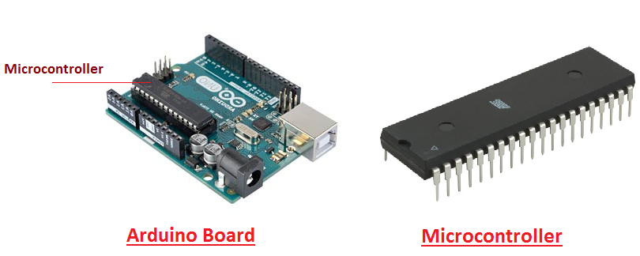

While learning microcontroller requires some expertise and skills.

Nevertheless, we can say every Arduino is basically a [microcontroller](https://www.theengineeringprojects.com/2018/03/introduction-to-microcontrollers.html) but not every microcontroller is an Arduino.

**Introduction to Arduino**

* **Arduino Uno** is a microcontroller board developed by Arduino.cc which is an open-source electronics platform mainly based on AVR microcontroller Atmega328.
* First Arduino project was started in Interaction Design Institute Ivrea in 2003 by David Cuartielles and Massimo Banzi with the intention of providing a cheap and flexible way to students and professional for controlling a number of devices in the real world.
* The current version of Arduino Uno comes with USB interface, 6 analog input pins, 14 I/O digital ports that are used to connect with external electronic circuits. Out of 14 I/O ports, 6 pins can be used for PWM output.
* It allows the designers to control and sense the external electronic devices in the real world

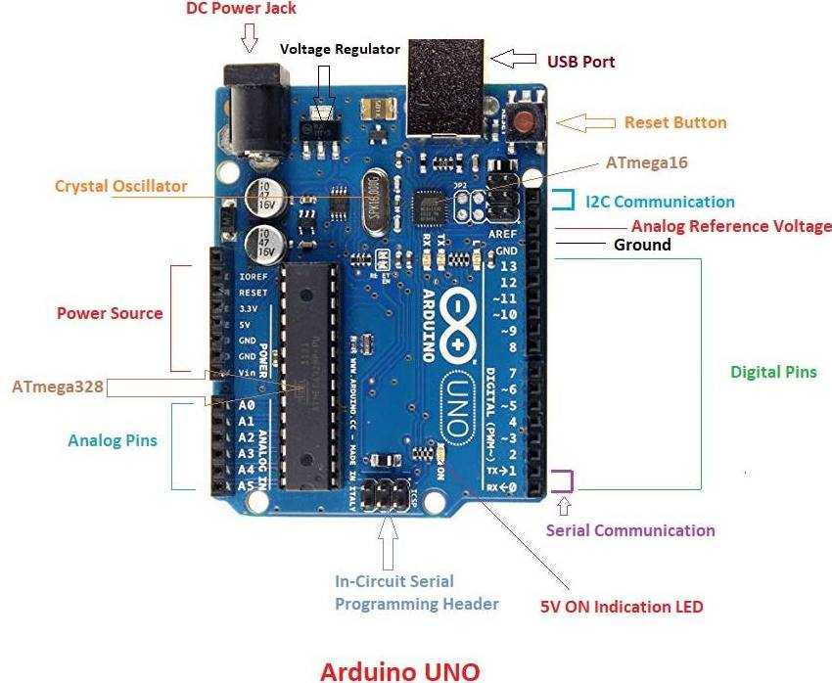

* This board comes with all the features required to run the controller and can be directly connected to the computer through USB cable that is used to transfer the code to the controller using IDE (Integrated Development Environment) software, mainly developed to program Arduino. IDE is equally compatible with Windows, MAC or Linux Systems, however, Windows is preferable to use. Programming languages like C and C++ are used in IDE.
* Apart from USB, battery or AC to DC adopter can also be used to power the board.
* Arduino Uno boards are quite similar to other boards in Arduino family in terms of use and functionality, however, Uno boards don’t come with FTDI USB to Serial driver chip.
* There are many versions of Uno boards available, however, Arduino Nano V3 and Arduino Uno are the most official versions that come with Atmega328 8-bit AVR Atmel microcontroller where RAM memory is 32KB.
* When nature and functionality of the task go complex, Mirco SD card can be added in the boards to make them store more information.

**Features of Arduino**

* Arduino Uno comes with USB interface i.e. USB port is added on the board to develop serial communication with the computer.
* [Atmega328](https://www.theengineeringprojects.com/2017/08/introduction-to-atmega328.html) microcontroller is placed on the board that comes with a number of features like timers, counters, interrupts, PWM, CPU, I/O pins and based on a 16MHz clock that helps in producing more frequency and number of instructions per cycle.

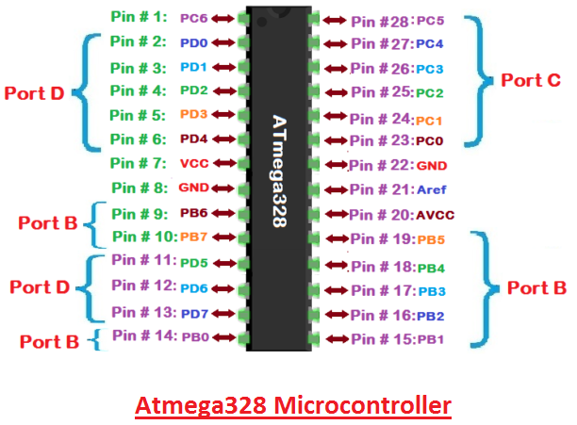

* It is an open source platform where anyone can modify and optimize the board based on the number of instructions and task they want to achieve.
* This board comes with a built-in regulation feature which keeps the voltage under control when the device is connected to the external device.
* Reset pin is added in the board that reset the whole board and takes the running program in the initial stage. This pin is useful when board hangs up in the middle of the running program; pushing this pin will clear everything up in the program and starts the program right from the beginning.
* There are 14 I/O digital and 6 analog pins incorporated in the board that allows the external connection with any circuit with the board. These pins provide the flexibility and ease of use to the external devices that can be connected through these pins. There is no hard and fast interface required to connect the devices to the board. Simply plug the external device into the pins of the board that are laid out on the board in the form of the header.
* The 6 analog pins are marked as A0 to A5 and come with a resolution of 10bits. These pins measure from 0 to 5V, however, they can be configured to the high range using analogReference() function and AREF pin.
* 13KB of flash memory is used to store the number of instructions in the form of code.
* Only 5 V is required to turn the board on, which can be achieved directly using USB port or external adopter, however, it can support external power source up to 12 V which can be regulated and limit to 5 V or 3.3 V based on the requirement of the project.

**Arduino Pinout**

* Arduino Uno is based on AVR microcontroller called Atmega328. This controller comes with 2KB SRAM, 32KB of flash memory, 1KB of EEPROM. Arduino Board comes with 14 digital pins and 6 analog pins. ON-chip ADC is used to sample these pins. A 16 MHz frequency crystal oscillator is equipped on the board. Following figure shows the pinout of the Arduino Uno Board

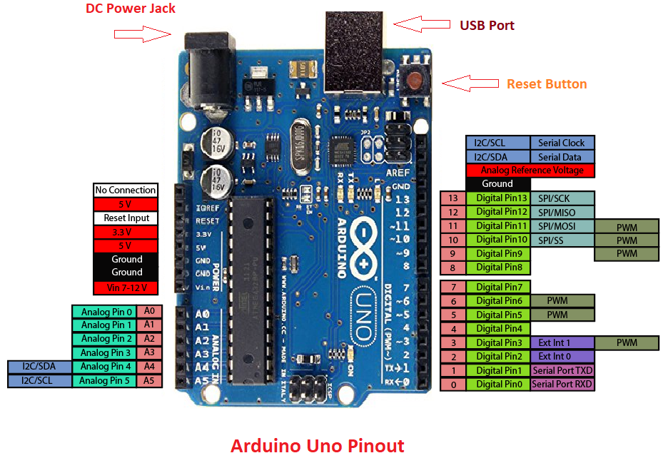

**Pin Description:**

There are several I/O digital and analog pins placed on the board which operates at 5V. These pins come with standard operating ratings ranging between 20mA to 40mA. Internal pull-up resistors are used in the board that limits the current exceeding from the given operating conditions. However, too much increase in current makes these resisters useless and damages the device.

**LED.** Arduino Uno comes with built-in LED which is connected through pin 13. Providing HIGH value to the pin will turn it ON and LOW will turn it OFF.

**Vin.** It is the input voltage provided to the Arduino Board. It is different than 5 V supplied through a USB port. This pin is used to supply voltage. If a voltage is provided through power jack, it can be accessed through this pin.

**5V.** This board comes with the ability to provide voltage regulation. 5V pin is used to provide output regulated voltage. The board is powered up using three ways i.e. USB, Vin pin of the board or DC power jack.

USB supports voltage around 5V while Vin and Power Jack support a voltage ranges between 7V to 20V. It is recommended to operate the board on 5V. It is important to note that, if a voltage is supplied through 5V or 3.3V pins, they result in bypassing the voltage regulation that can damage the board if voltage surpasses from its limit.

**GND.** These are ground pins. More than one ground pins are provided on the board which can be used as per requirement.

**Reset.** This pin is incorporated on the board which resets the program running on the board. Instead of physical reset on the board, IDE comes with a feature of resetting the board through programming.

**IOREF.** This pin is very useful for providing voltage reference to the board. A shield is used to read the voltage across this pin which then select the proper power source.

**PWM.** PWM is provided by 3, 5, 6,9,10, 11pins. These pins are configured to provide 8-bit output PWM.

**SPI.** It is known as Serial Peripheral Interface. Four pins 10(SS), 11(MOSI), 12(MISO), 13(SCK) provide SPI communication with the help of SPI library.

**AREF.** It is called Analog Reference. This pin is used for providing a reference voltage to the analog inputs.

**TWI.** It is called Two-wire Interface. TWI communication is accessed through Wire Library. A4 and A5 pins are used for this purpose.

**Serial Communication.** Serial communication is carried out through two pins called Pin 0 (Rx) and Pin 1 (Tx).

Rx pin is used to receive data while Tx pin is used to transmit data.

**External Interrupts.** Pin 2 and 3 are used for providing external interrupts. An interrupt is called by providing LOW or changing value.

### **Arduino Uno Technical Specifications**

|  |  |
| --- | --- |
| Microcontroller | [ATmega328P](https://components101.com/microcontrollers/atmega328p-pinout-features-datasheet) – 8 bit AVR family microcontroller |
| Operating Voltage | 5V |
| Recommended Input Voltage | 7-12V |
| Input Voltage Limits | 6-20V |
| Analog Input Pins | 6 (A0 – A5) |
| Digital I/O Pins | 14 (Out of which 6 provide PWM output) |
| DC Current on I/O Pins | 40 mA |
| DC Current on 3.3V Pin | 50 mA |
| Flash Memory | 32 KB (0.5 KB is used for Bootloader) |
| SRAM | 2 KB |
| EEPROM | 1 KB |
| Frequency (Clock Speed) | 16 MHz |

**Communication and Programming:**

Arduino Uno comes with an ability of interfacing with other other Arduino boards, microcontrollers and computer. The Atmega328 placed on the board provides serial communication using pins like Rx and Tx.

The Atmega16U2 incorporated on the board provides a pathway for serial communication using USB com drivers. Serial monitor is provided on the IDE software which is used to send or receive text data from the board. If LEDs placed on the Rx and Tx pins will flash, they indicate the transmission of data.

Arduino Uno is programmed using Arduino Software which a cross-platform application called IDE is written in Java. The AVR microcontroller Atmega328 laid out on the base comes with built-in boot loader that sets you free from using a separate burner to upload the program on the board.



**Applications:**

Arduino Uno comes with a wide range of applications. A larger number of people are using Arduino boards for developing sensors and instruments that are used in scientific research. Following are some main applications of the board.

* [Embedded System](https://www.theengineeringprojects.com/2016/10/what-is-embedded-systems.html)
* Security and Defense System
* Digital Electronics and Robotics
* Parking Lot Counter
* Weighing Machines
* Traffic Light Count Down Timer
* Medical Instrument
* Emergency Light for Railways
* Home Automation
* Industrial Automation

There are a lot of other microcontrollers available in the market that are more powerful and cheap as compared to Arduino board. So, why you prefer Arduino Uno?

Actually, Arduino comes with a big community that is developing and sharing the knowledge with a wide range of audience. Quick support is available pertaining to technical aspects of any electronic project. When you decide Arduino board over other controllers, you don’t need to arrange extra peripherals and devices as most of the functions are readily available on the board that makes your project economical in nature and free from a lot of technical expertise.

**DHT11 SENSOR (TEMPERATURE/HUMIDITY):**

## The DHT11 is a basic, low-cost digital temperature and humidity sensor. It uses a capacitive humidity sensor and a thermistor to measure the surrounding air, and spits out a digital signal on the data pin (no analog input pins needed). It’s fairly simple to use, but requires careful timing to grab data. The only real downside of this sensor is you can only get new data from it once every 2 seconds.

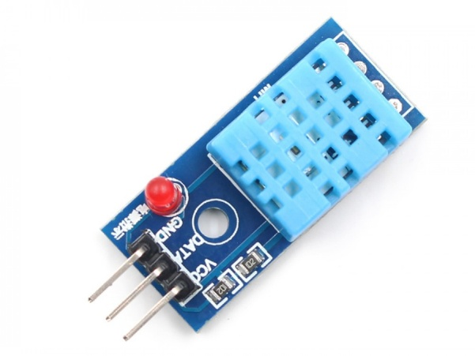

## Technical Specifications:

|  |  |  |  |  |  |
| --- | --- | --- | --- | --- | --- |
| Item | Measurement  Range | Humidity  Accuracy | Temperature Accuracy | Resolution | Package |
| DHT11 | 20-90%RH  0-500C | ±5％RH | ±20C | 1 | 4 Pin Single Row |

**Typical Application:**

Note: 3Pin – Null; MCU = Micro-computer Unite or single chip Computer

When the connecting cable is shorter than 20 metres, a 5K pull-up resistor is recommended;

When the connecting cable is longer than 20 metres, choose an appropriate pull-up resistor as

Needed.

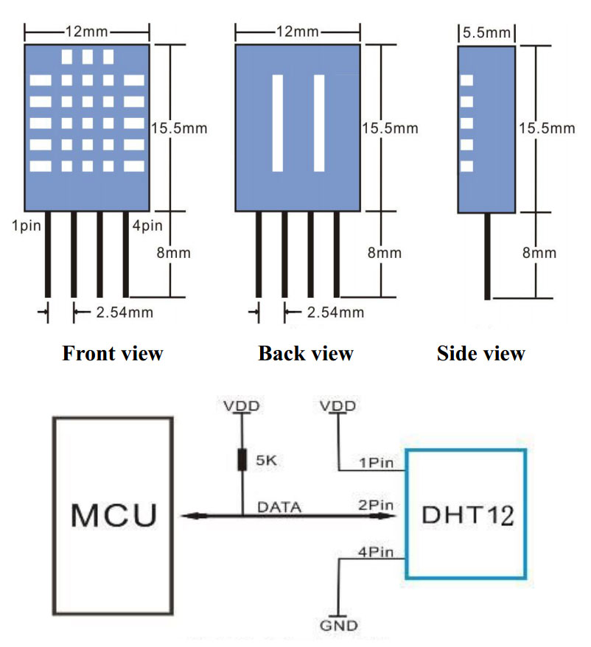

**Power and Pin**

DHT11’s power supply is 3-5.5V DC. When power is supplied to the sensor, do not send any instruction to the sensor in within one second in order to pass the unstable status. One Capacitor valued 100nF can be added between VDD and GND for power filtering.

**Soil Moisture Sensor:**

The soil moisture sensor is one [kind of sensor](https://www.elprocus.com/accelerometer-sensor-working-and-applications/) used to gauge the volumetric content of water within the soil. As the straight gravimetric dimension of soil moisture needs eliminating, drying, as well as sample weighting. These sensors measure the volumetric water content not directly with the help of some other rules of soil like dielectric constant, electrical resistance, otherwise interaction with neutrons, and replacement of the moisture content.

The relation among the calculated property as well as moisture of soil should be adjusted & may change based on ecological factors like temperature, type of soil, otherwise electric conductivity. The microwave emission which is reflected can be influenced by the moisture of soil as well as mainly used in agriculture and remote sensing within hydrology.

### **Soil Moisture Sensor Pin Configuration**

The FC-28 soil moisture sensor includes 4-pins

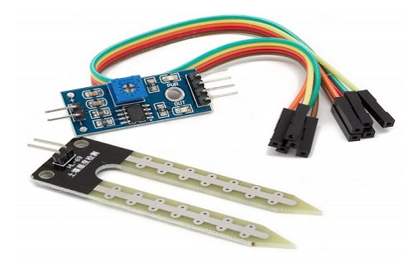

* VCC pin is used for power
* A0 pin is an analog output
* D0 pin is a digital output
* GND pin is a Ground

This module also includes a potentiometer that will fix the threshold value, & the value can be evaluated by the [comparator-LM393](https://www.elprocus.com/lm393-ic-pin-configuration-circuit-diagram-and-its-working/). The [LED](https://www.elprocus.com/bipolar-led-driver-circuit-working-application/) will turn on/off based on the threshold value.

### **Working Principle**

This sensor mainly utilizes capacitance to gauge the water content of the soil (dielectric permittivity). The working of this sensor can be done by inserting this sensor into the earth and the status of the water content in the soil can be reported in the form of a percent.

This sensor makes it perfect to execute experiments within science courses like environmental science, agricultural science, biology, soil science, botany, and horticulture.



### **Specifications**

The specification of this sensor includes the following.

* The required voltage for working is 5V
* The required current for working is <20mA
* Type of interface is analog
* The required working temperature of this sensor is 10°C~30°C

**Ultrasonic sensor**

An ultrasonic sensor transmit ultrasonic waves into the air and detects reflected waves from an object. There are many applications for ultrasonic sensors, such as in intrusion alarm systems, automatic door openers and backup sensors for automobiles.

Accompanied by the rapid development of information processing technology, new fields of application, such as factory automation equipment and car electronics, are increasing and should continue to do so. Using its unique piezoelectric ceramics manufacturing technology developed over many years, Murata has developed various types of ultrasonic sensors which are compact and yet have very high performance. The information contained in this catalog will help you to make effective use of our ultrasonic sensors.

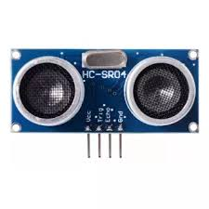

**HC-SR04 Sensor Features**

* Operating voltage: +5V
* Theoretical  Measuring Distance: 2cm to 450cm
* Practical Measuring Distance: 2cm to 80cm
* Accuracy: 3mm
* Measuring angle covered: <15°
* Operating Current: <15mA
* Operating Frequency: 40Hz

**HC-SR04 Ultrasonic Sensor - Working**

As shown above the HC-SR04 Ultrasonic (US) sensor is a 4 pin module, whose pin names are Vcc, Trigger, Echo and Ground respectively. This sensor is a very popular sensor used in many applications where measuring distance or sensing objects are required. The module has two eyes like projects in the front which forms the Ultrasonic transmitter and Receiver. The sensor works with the simple high school formula that

**Distance = Speed × Time**

The Ultrasonic transmitter transmits an ultrasonic wave, this wave travels in air and when it gets objected by any material it gets reflected back toward the sensor this reflected wave is observed by the Ultrasonic receiver module as shown in the picture below

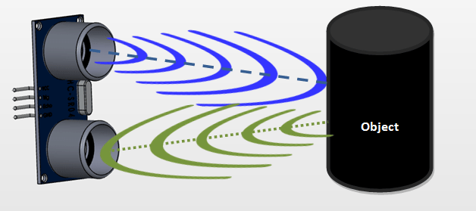

Now, to calculate the distance using the above formulae, we should know the Speed and time. Since we are using the Ultrasonic wave we know the universal speed of US wave at room conditions which is 330m/s. The circuitry inbuilt on the module will calculate the time taken for the US wave to come back and turns on the echo pin high for that same particular amount of time, this way we can also know the time taken. Now simply calculate the distance using a microcontroller or microprocessor.

### How to use the HC-SR04 Ultrasonic Sensor

**HC-SR04 distance sensor** is commonly used with both microcontroller and microprocessor platforms like Arduino, ARM, PIC, Raspberry Pie etc. The following guide is universally since it has to be followed irrespective of the type of computational device used.

  Power the Sensor using a regulated +5V through the Vcc ad Ground pins of the sensor. The current consumed by the sensor is less than 15mA and hence can be directly powered by the on board 5V pins (If available). The Trigger and the Echo pins are both I/O pins and hence they can be connected to I/O pins of the microcontroller. To start the measurement, the trigger pin has to be made high for 10uS and then turned off. This action will trigger an ultrasonic wave at frequency of 40Hz from the transmitter and the receiver will wait for the wave to return. Once the wave is returned after it getting reflected by any object the Echo pin goes high for a particular amount of time which will be equal to the time taken for the wave to return back to the sensor.

The amount of time during which the Echo pin stays high is measured by the MCU/MPU as it gives the information about the time taken for the wave to return back to the Sensor. Using this information the distance is measured as explained in the above heading.

**LCD:**

LCD (Liquid Crystal Display) is the innovation utilized in scratch pad shows and other littler PCs. Like innovation for light-producing diode (LED) and gas-plasma, LCDs permit presentations to be a lot more slender than innovation for cathode beam tube (CRT). LCDs expend considerably less power than LED shows and gas shows since they work as opposed to emanating it on the guideline of blocking light.

A LCD is either made with a uninvolved lattice or a showcase network for dynamic framework show. Likewise alluded to as a meager film transistor (TFT) show is the dynamic framework LCD. The uninvolved LCD lattice has a matrix of conductors at every crossing point of the network with pixels. Two conductors on the lattice send a current to control the light for any pixel. A functioning framework has a transistor situated at every pixel crossing point, requiring less current to control the luminance of a pixel.

Some aloof network LCD's have double filtering, which implies they examine the matrix twice with current in the meantime as the first innovation took one sweep. Dynamic lattice, be that as it may, is as yet a higher innovation.

A 16x2 LCD show is an essential module that is generally utilized in various gadgets and circuits. These modules more than seven sections and other multi fragment LEDs are liked. The reasons being: LCDs are affordable; effectively programmable; have no restriction of showing exceptional and even custom characters (not at all like in seven fragments), movements, etc.

A 16x2 LCD implies 16 characters can be shown per line and 2 such lines exist. Each character is shown in a lattice of 5x7 pixels in this LCD. There are two registers in this LCD, in particular Command and Data.

The directions given to the LCD are put away by the order register. An order is a direction given to LCD to play out a predefined assignment, for example, introducing it, clearing its screen, setting the situation of the cursor, controlling presentation, and so forth. The information register will store the information that will be shown on the LCD. The information is the character's ASCII incentive to show on the LCD.

**Data/Signals/Execution of LCD**

Now that was all about the signals and the hardware. Let us come to data, signals and execution.

Two types of signals are accepted by LCD, one is data and one is control. The LCD module recognizes these signals from the RS pin status. By pulling the R / W pin high, data can now also be read from the LCD display. Once the E pin has been pulsed, the LCD display reads and executes data at the falling edge of the pulse, the same for the transmission case.

It takes 39-43μS for the LCD display to place a character or execute a command. It takes 1.53ms to 1.64ms except for clearing display and searching for cursor to the home position.

Any attempt to send data before this interval may result in failure in some devices to read data or execute the current data. Some devices compensate for the speed by storing some temporary registers with incoming data.

There are two RAMs for LCD displays, namely DDRAM and CGRAM. DDRAM registers the position in which the character would be displayed in the ASCII chart. Each DDRAM byte represents every single position on the display of the LCD.

The DDRAM information is read by the LCD controller and displayed on the LCD screen. CGRAM enables users to define their personalized characters. Address space is reserved for users for the first 16 ASCII characters.

Users can easily display their custom characters on the LCD screen after CGRAM has been set up to display characters.

**Images of LCD Display:-**

[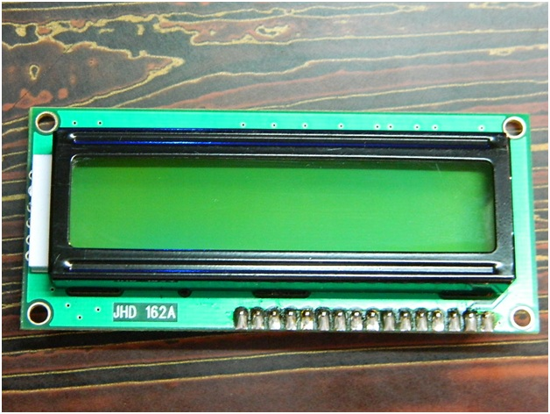](http://www.circuitstoday.com/wp-content/uploads/2012/02/LCD-Display-Front-Side.jpg)

**LCD – Front View**

[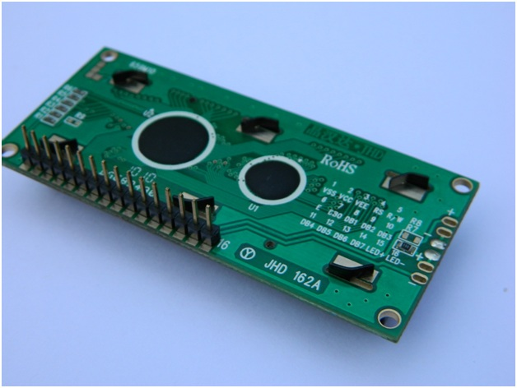](http://www.circuitstoday.com/wp-content/uploads/2012/02/lcd-display-back-side.jpg)

**LCD – Back View**

**Pin Diagram:**

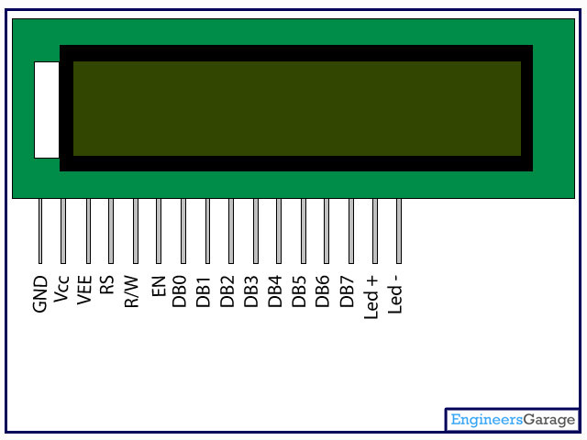

**Pin Description:**

|  |  |  |
| --- | --- | --- |
| Pin No | Function | Name |
| 1 | Ground (0V) | Ground |
| 2 | Supply voltage; 5V (4.7V – 5.3V) | Vcc |
| 3 | Contrast adjustment; through a variable resistor | VEE |
| 4 | Selects command register when low; and data register when high | Register Select |
| 5 | Low to write to the register; High to read from the register | Read/write |
| 6 | Sends data to data pins when a high to low pulse is given | Enable |
| 7 | 8-bit data pins | DB0 |
| 8 | DB1 |
| 9 | DB2 |
| 10 | DB3 |
| 11 | DB4 |
| 12 | DB5 |
| 13 | DB6 |
| 14 | DB7 |
| 15 | Backlight VCC (5V) | Led+ |
| 16 | Backlight Ground (0V) | Led- |

**RS (Register select)**

A 16X2 LCD has two order and information registers. The determination of the register is utilized to change starting with one register then onto the next. RS=0 for the register of directions, while RS=1 for the register of information.

**Command Register**

The guidelines given to the LCD are put away by the direction register. An order is a direction given to LCD to play out a predefined assignment, for example, instating it, clearing its screen, setting the situation of the cursor, controlling showcase, and so on. Order preparing happens in the direction register.

**Data Register:**

The information register will store the information that will be shown on the LCD. The information is the character's ASCII incentive to show on the LCD. It goes to the information register and is prepared there when we send information to the LCD. While choosing RS=1, the information register.

**Read and Write Mode of LCD:**

As stated, the LCD itself comprises of an interface IC. This interface IC can be perused or composed by the MCU. A large portion of the occasions we're simply going to keep in touch with the IC since perusing will make it increasingly perplexing and situations like that are exceptionally uncommon.Information such as cursor position, status completion interrupts, etc. can be read if necessary.

**LCD Commands:**

There are some preset commands in the LCD that we need to send to the LCD via some microcontroller. The following are some important command instructions:

|  |  |  |
| --- | --- | --- |
| **Sr. No.** | **Hex Code** | **Command to LCD instruction Register** |
| 1 | 01 | Clear display screen |
| 2 | 02 | Return home |
| 3 | 04 | Decrement cursor (shift cursor to left) |
| 4 | 06 | Increment cursor (shift cursor to right) |
| 5 | 05 | Shift display right |
| 6 | 07 | Shift display left |
| 7 | 08 | Display off, cursor off |
| 8 | 0A | Display off, cursor on |
| 9 | 0C | Display on, cursor off |
| 10 | 0E | Display on, cursor blinking |
| 11 | 0F | Display on, cursor blinking |
| 12 | 10 | Shift cursor position to left |
| 13 | 14 | Shift cursor position to right |
| 14 | 18 | Shift the entire display to the left |
| 15 | 1C | Shift the entire display to the right |
| 16 | 80 | Force cursor to beginning ( 1st line) |
| 17 | C0 | Force cursor to beginning ( 2nd line) |
| 18 | 38 | 2 lines and 5×7 matrix |

## Command codes for LCD

**Block Diagram of LCD Display:-**

**[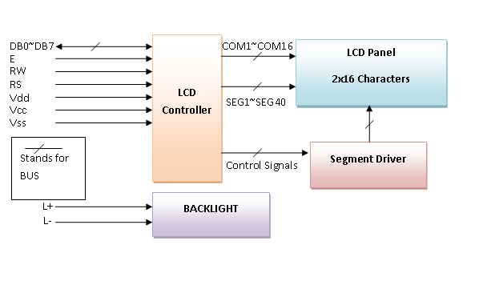](http://www.circuitstoday.com/wp-content/uploads/2012/02/LCD-Display-Block-Diagram.png)**

**Control and display commands**

|  |  |  |  |  |  |  |  |  |  |  |  |  |
| --- | --- | --- | --- | --- | --- | --- | --- | --- | --- | --- | --- | --- |
| **Instruction** | **Instruction Code** | | | | | | | | | | **Instruction Code Description** | **Execution time** |
| RS | R/W | DB7 | DB6 | DB5 | DB4 | DB3 | DB2 | DB1 | DB0 |
| Read Data From RAM | 1 | 1 | D7 | D6 | D5 | D4 | D3 | D2 | D1 | D0 | Read data from internal RAM | 1.53-1.64ms |
| Write data to RAM | 1 | 0 | D7 | D6 | D5 | D4 | D3 | D2 | D1 | D0 | Write data into internal RAM (DDRAM/CGRAM) | 1.53-1.64ms |
| Busy flag & Address | 0 | 1 | BF | AC6 | AC5 | AC4 | AC3 | AC2 | AC1 | AC0 | Busy flag (BF: 1→ LCD Busy) and contents of address counter in bits AC6-AC0. | 39 µs |
| Set DDRAM Address | 0 | 0 | 1 | AC6 | AC5 | AC4 | AC3 | AC2 | AC1 | AC0 | Set DDRAM address in address counter. | 39 µs |
| Set CGRAM Address | 0 | 0 | 0 | 1 | AC5 | AC4 | AC3 | AC2 | AC1 | AC0 | Set CGRAM Address in address counter. | 39 µs |
| Function Set | 0 | 0 | 0 | 0 | 1 | DL | N | F | X | X | Set interface data length (DL: 4bit/8bit), Numbers of display line (N: 1-line/2-line) display font type (F:0→ 5×8 dots, F:1→ 5×11 dots) | 39 µs |
| Cursor or Display Shift | 0 | 0 | 0 | 0 | 0 | 1 | S/C | R/L | X | X | Set cursor moving and display shift control bit, and the direction without changing DDRAM data | 39 µs |
| Display & Cursor On/Off | 0 | 0 | 0 | 0 | 0 | 0 | 1 | D | C | B | Set Display(D),Cursor(C) and cursor blink(b) on/off control | 39 µs |
| Entry Mode Set | 0 | 0 | 0 | 0 | 0 | 0 | 0 | 1 | I/D | SH | Assign cursor moving direction and enable shift entire display. | 0µs |
| Return Home | 0 | 0 | 0 | 0 | 0 | 0 | 0 | 0 | 1 | X | Set DDRAM Address to “00H” from AC and return cursor to its original position if shifted. | 43µs |
| Clear Display | 0 | 0 | 0 | 0 | 0 | 0 | 0 | 0 | 0 | 1 | Write “20H” to DDRAM and set DDRAM Address to “00H” from AC | 43µs |

**4-bit and 8-bit Mode of LCD:**

The LCD can work in two striking modes, the 4-bit mode and the 8-bit mode. We send the information snack through snack in 4 bit mode, first upper chomp, by then lower snack. For those of you who don't have the foggiest idea what a goody is: a chomp is a four-piece gathering, so a byte's lower four bits (D0-D3) are the lower snack, while a byte's upper four bits (D4-D7) are the higher snack. This enables us to send 8 bit data. This connects with us to send 8 bit data. Whereas in 8 bit mode we can send the 8-bit information truly in one stroke since we utilize all the 8 information lines. You need to get it now; yes 8-bit mode is quicker and immaculate than 4-bit mode. In any case, the fundamental shortcoming is that it needs 8 microcontroller-related information lines. This will result in our MCU coming up short on I/O pins, so 4-bit mode is extensively utilized. To set these modes, no control pins are used.

**Relay:**

**What is a relay?**

A relay is an electromagnetic switch that is used to turn on and turn off a circuit by a low power signal, or where several circuits must be controlled by one signal.

Most of the high end industrial application devices have relays for their effective working. Relays are simple switches which are operated both electrically and mechanically. Relays consist of an electromagnet and also a set of contacts. The switching mechanism is carried out with the help of the electromagnet. There are also other operating principles for its working. But they differ according to their applications. Most of the devices have the application of relays.

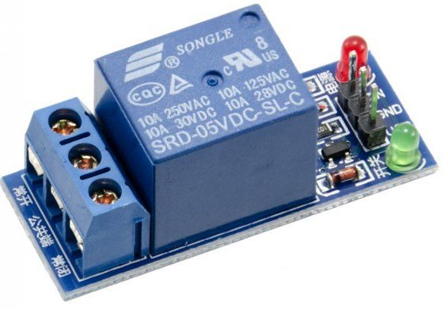

### **Pin Diagram:**

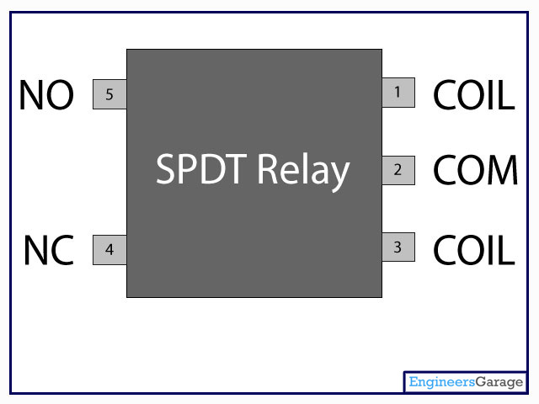

**Why is a relay used?**

The main operation of a relay comes in places where only a low-power signal can be used to control a circuit. It is also used in places where only one signal can be used to control a lot of circuits. The application of relays started during the invention of telephones. They played an important role in switching calls in telephone exchanges. They were also used in long distance telegraphy. They were used to switch the signal coming from one source to another destination. After the invention of computers they were also used to perform Boolean and other logical operations. The high end applications of relays require high power to be driven by electric motors and so on. Such relays are called contactors.

### **Relay Design**

* There are only four main parts in a relay. They are
* Electromagnet
* Movable Armature
* Switch point contacts
* Spring

The figures given below show the actual design of a simple relay.

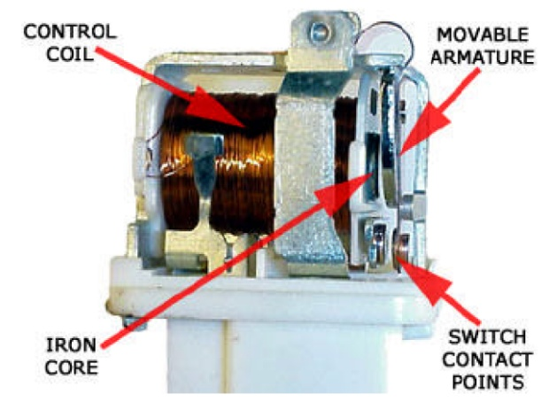

**Relay Construction**

It is an electro-magnetic relay with a wire coil, surrounded by an iron core. A path of very low reluctance for the magnetic flux is provided for the movable armature and also the switch point contacts.

The movable armature is connected to the yoke which is mechanically connected to the switch point contacts. These parts are safely held with the help of a spring. The spring is used so as to produce an air gap in the circuit when the relay becomes de-energized.

### **How relay works?**

The relay function can be better understood by explaining the following diagram given below.

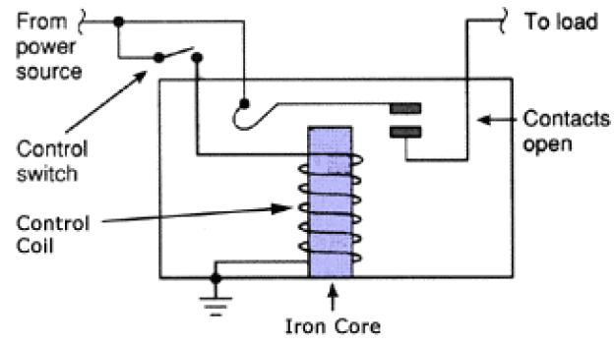

**Relay Design**

The diagram shows an inner section diagram of a relay. An iron core is surrounded by a control coil. As shown, the power source is given to the electromagnet through a control switch and through contacts to the load. When current starts flowing through the control coil, the electromagnet starts energizing and thus intensifies the magnetic field. Thus the upper contact arm starts to be attracted to the lower fixed arm and thus closes the contacts causing a short circuit for the power to the load. On the other hand, if the relay was already de-energized when the contacts were closed, then the contact move oppositely and make an open circuit.

As soon as the coil current is off, the movable armature will be returned by a force back to its initial position. This force will be almost equal to half the strength of the magnetic force. This force is mainly provided by two factors. They are the spring and also gravity.

Relays are mainly made for two basic operations. One is low voltage application and the other is high voltage. For low voltage applications, more preference will be given to reduce the noise of the whole circuit. For high voltage applications, they are mainly designed to reduce a phenomenon called arcing.

### **Relay Basics**

The basics for all the relays are the same. Take a look at a 4 pin relay shown below. There are two colors shown. The green color represents the control circuit and the red color represents the load circuit. A small control coil is connected onto the control circuit. A switch is connected to the load. This switch is controlled by the coil in the control circuit. Now let us take the different steps that occur in a relay.

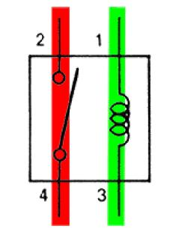

**Relay operation**

* **Energized Relay (ON)**

As shown in the circuit, the current flowing through the coils represented by pins 1 and 3 causes a magnetic field to be aroused. This magnetic field causes the closing of the pins 2 and 4. Thus the switch plays an important role in the relay working. As it is a part of the load circuit, it is used to control an electrical circuit that is connected to it. Thus, when the electrical relay in energized the current flow will be through the pins 2 and 4.

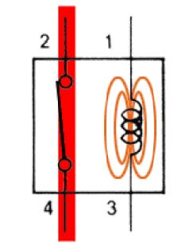

**Energized Relay (ON)**

* **De – Energized Relay (OFF)**

As soon as the current flow stops through pins 1 and 3, the relay switch opens and thus the open circuit prevents the current flow through pins 2 and 4. Thus the relay becomes de-energized and thus in off position.

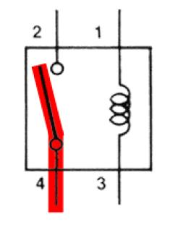

**De-Energized Relay (OFF)**

**In simple, when a voltage is applied to pin 1, the electromagnet activates, causing a magnetic field to be developed, which goes on to close the pins 2 and 4 causing a closed circuit. When there is no voltage on pin 1, there will be no electromagnetic force and thus no magnetic field. Thus the switches remain open.**

### **Pole and Throw**

Relays have the exact working of a switch. So, the same concept is also applied. A relay is said to switch one or more poles. Each pole has contacts that can be thrown in mainly three ways. They are

* **Normally Open Contact (NO):**  NO contact is also called a make contact. It closes the circuit when the relay is activated. It disconnects the circuit when the relay is inactive.
* **Normally Closed Contact (NC):**  NC contact is also known as break contact. This is opposite to the NO contact. When the relay is activated, the circuit disconnects. When the relay is deactivated, the circuit connects.
* **Change-over (CO) / Double-throw (DT) Contacts:**  This type of contacts are used to control two types of circuits. They are used to control a NO contact and also a NC contact with a common terminal. According to their type they are called by the names **break before make** and **make before break** contacts.

Relays can be used to control several circuits by just one signal. A relay switches one or more poles, each of whose contacts can be thrown by energizing the coil.

Relays are also named with designations like

* **Single Pole Single Throw (SPST)**: The SPST relay has a total of four terminals. Out of these two terminals can be connected or disconnected. The other two terminals are needed for the coil to be connected.
* **Single Pole Double Throw (SPDT):** The SPDT relay has a total of five terminals. Out of these two are the coil terminals. A common terminal is also included which connects to either of two others.
* **Double Pole Single Throw (DPST):**  The DPST relay has a total of six terminals. These terminals are further divided into two pairs. Thus they can act as two SPST which are actuated by a single coil. Out of the six terminals two of them are coil terminals.
* **Double Pole Double Throw (DPDT)**: The DPDT relay is the biggest of all. It has mainly eight relay terminals. Out of these two rows are designed to be change over terminals. They are designed to act as two SPDT relays which are actuated by a single coil.

### **Relay Applications**

* A relay circuit is used to realize logic functions. They play a very important role in providing safety critical logic.
* Relays are used to provide time delay functions. They are used to time the delay open and delay close of contacts.
* Relays are used to control high voltage circuits with the help of low voltage signals. Similarly they are used to control high current circuits with the help of low current signals.
* They are also used as protective relays. By this function all the faults during transmission and reception can be detected and isolated.

#### **Application of Overload Relay**

Overload relay is an electro-mechanical device that is used to safeguard motors from overloads and power failures. Overload relays are installed in motors to safeguard against sudden current spikes that may damage the motor. An overload relay switch works in characteristics with current over time and is different from circuit breakers and fuses, where a sudden trip is made to turn off the motor. The most widely used overload relay is the thermal overload relay where a bimetallic strip is used to turn off the motor. This strip is set to make contact with a contactor by bending itself with rising temperatures due to excess current flow. The contact between the strip and the contactor causes the contactor to de-energize and restricts the power to the motor, and thus turns it off.

Another type of overload motor is the electronic type which continuously watches the motor current, whereas the thermal overload relay shuts off the motor depending on the rise of temperature/heat of the strip.

All overload relays available to buy comes in different specifications, the most important of them being the current ranges and response time. Most of them are designed to automatically reset to work after the motor is turned back on.

### **Relay Selection**

You must note some factors while selecting a particular relay. They are

* Protection Different protections like contact protection and coil protection must be noted. Contact protection helps in reducing arcing in circuits using inductors. Â Coil protection helps in reducing surge voltage produced during switching.
* Look for a standard relay with all regulatory approvals.
* Switching time Ask for high speed switching relays if you want one.
* Ratings There are current as well as voltage ratings. The current ratings vary from a few amperes to about 3000 amperes. Â In case of voltage ratings, they vary from 300 Volt AC to 600 Volt AC. There are also high voltage relays of about 15,000 Volts.
* Type of contact used whether it is a NC or NO or closed contact.
* Select Make before Break or Break before Make contacts wisely.
* Isolation between coil circuit and contacts

**Buzzer:**

A buzzer or beeper is an audio signaling device, which may be mechanical, electromechanical, or piezoelectric. Typical uses of buzzers and beepers include alarm devices, timers and confirmation of user input such as a mouse click or keystroke. Buzzer is an integrated structure of electronic transducers, DC power supply, widely used in computers, printers, copiers, alarms, electronic toys, automotive electronic equipment, telephones, timers and other electronic products for sound devices. Active buzzer 5V Rated power can be directly connected to a continuous sound, this section dedicated sensor expansion module and the board in combination, can complete a simple circuit design, to "plug and play.

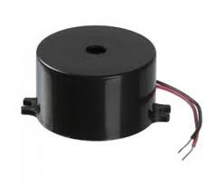

**Buzzer Pin Configuration**

|  |  |  |
| --- | --- | --- |
| **Pin Number** | **Pin Name** | **Description** |
| 1 | Positive | Identified by (+) symbol or longer terminal lead. Can be powered by 5V DC |
| 2 | Negative | Identified by short terminal lead. Typically connected to the ground of the circuit |

**Buzzer Features and Specifications**

* Rated Voltage: 6V DC
* Operating Voltage: 4-8V DC
* Rated current: <30mA
* Sound Type: Continuous Beep
* Resonant Frequency: ~2300 Hz
* Small and neat sealed package
* Breadboard and Perf board friendly

**How to use a Buzzer**

A **buzzer**is a small yet efficient component to add sound features to our project/system. It is very small and compact 2-pin structure hence can be easily used on [breadboard](https://components101.com/misc/breadboard-connections-uses-guide), Perf Board and even on PCBs which makes this a widely used component in most electronic applications.

There are two types are buzzers that are commonly available. The one shown here is a simple buzzer which when powered will make a Continuous Beeeeeeppp.... sound, the other type is called a readymade buzzer which will look bulkier than this and will produce a Beep. Beep. Beep. Sound due to the internal oscillating circuit present inside it. But, the one shown here is most widely used because it can be customized with help of other circuits to fit easily in our application.

This buzzer can be used by simply powering it using a DC power supply ranging from 4V to 9V. A simple 9V battery can also be used, but it is recommended to use a regulated +5V or +6V DC supply. The buzzer is normally associated with a switching circuit to turn ON or turn OFF the buzzer at required time and require interval.

**Applications of Buzzer**

* Alarming Circuits, where the user has to be alarmed about something
* Communication equipment’s
* Automobile electronics
* Portable equipment’s, due to its compact size

**DC Water Pump:**

DC powered pumps use direct current from motor, battery, or solar power to move fluid in a variety of ways. Motorized pumps typically operate on 6, 12, 24, or 32 volts of DC power. Solar-powered DC pumps use photovoltaic (PV) panels with solar cells that produce direct current when exposed to sunlight.

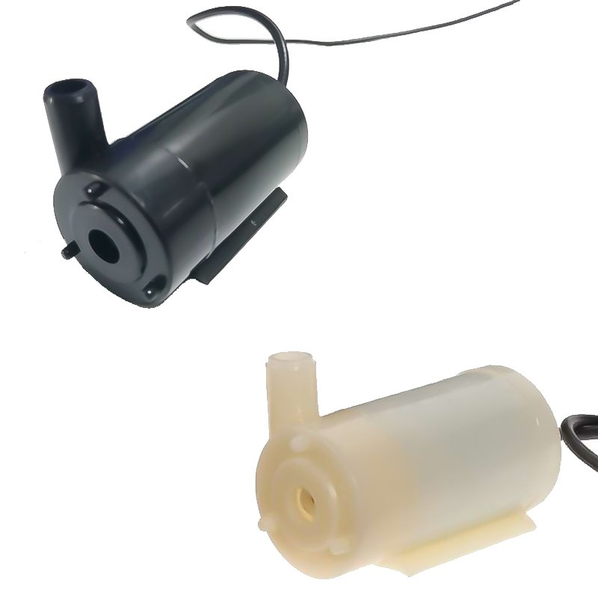

**DC Pump Classification:**

1. Brush [DC water pump](http://www.spminipump.com/product/index-7.html)

2. Brushless DC magnetic drive isolated water pump

3. Brushless motor [DC water pump](http://www.spminipump.com/product/index-7.html)

**Working principle:**

**1. Working principle of brushed**[DC water pump](http://www.spminipump.com/product/index-7.html)**：**

**Disadvantages:**As long as the motor rotates the carbon brushes, they will wear out. When the water pump runs to a certain level, the carbon brush wear gap will increase and the sound will increase. After hundreds of hours of continuous operation, the carbon brushes will not be able to change direction. Up.

**Advantages:**low price.

**2. The working principle of brushless motor**[DC water pump](http://www.spminipump.com/product/index-7.html)**：**

The motor-type brushless DC pump is composed of a brushless DC motor and an impeller. The shaft of the motor is connected to the impeller.

**Disadvantages:**There is a gap between the stator and the rotor of the water pump. After a long time of use, the water will penetrate into the motor and the motor will easily burn out.

**Advantages:**The brushless DC motor has been standardized and mass-produced by specialized manufacturers, with relatively low cost and high efficiency.

**GSM**

GSM is a mobile communication modem; it is stands for global system for mobile communication (GSM). The idea of GSM was developed at Bell Laboratories in 1970.  It is widely used mobile communication system in the world. GSM is an open and digital cellular technology used for transmitting mobile voice and data services operates at the 850MHz, 900MHz, 1800MHz and 1900MHz frequency bands.

GSM system was developed as a digital system using time division multiple access (TDMA) technique for communication purpose. A GSM digitizes and reduces the data, then sends it down through a channel with two different streams of client data, each in its own particular time slot. The digital system has an ability to carry 64 kbps to 120 Mbps of data rates.

There are various cell sizes in a GSM system such as macro, micro, pico and umbrella cells. Each cell varies as per the implementation domain. There are five different cell sizes in a GSM network macro, micro, pico and umbrella cells. The coverage area of each cell varies according to the implementation environment.

### Time Division Multiple Access

TDMA technique relies on assigning different time slots to each user on the same frequency. It can easily adapt to data transmission and voice communication and can carry 64kbps to 120Mbps of data rate.

### GSM Architecture

A GSM network consists of the following components:

* **A Mobile Station:**  It is the mobile phone which consists of the transceiver, the display and the processor and is controlled by a SIM card operating over the network.
* **Base Station Subsystem:** It acts as an interface between the mobile station and the network subsystem. It consists of the Base Transceiver Station which contains the radio transceivers and handles the protocols for communication with mobiles. It also consists of the Base Station Controller which controls the Base Transceiver station and acts as a interface between the mobile station and mobile switching centre.
* **Network Subsystem:** It provides the basic network connection to the mobile stations. The basic part of the Network Subsystem is the Mobile Service Switching Centre which provides access to different networks like ISDN, PSTN etc. It also consists of the Home Location Register and the Visitor Location Register which provides the call routing and roaming capabilities of GSM. It also contains the Equipment Identity Register which maintains an account of all the mobile equipments wherein each mobile is identified by its own IMEI number. IMEI stands for International Mobile Equipment Identity.

### Features of GSM Module:

* Improved spectrum efficiency
* International roaming
* Compatibility with integrated services digital network (ISDN)
* Support for new services.
* SIM phonebook management
* Fixed dialing number (FDN)
* Real time clock with alarm management
* High-quality speech
* Uses encryption to make phone calls more secure
* Short message service (SMS)

The security strategies standardized for the GSM system make it the most secure telecommunications standard currently accessible. Although the confidentiality of a call and secrecy of the GSM subscriber is just ensured on the radio channel, this is a major step in achieving end-to- end security.

### GSM Modem

A GSM modem is a device which can be either a mobile phone or a modem device which can be used to make a computer or any other processor communicate over a network. A GSM modem requires a SIM card to be operated and operates over a network range subscribed by the network operator.  It can be connected to a computer through serial, USB or Bluetooth connection.

A GSM modem can also be a standard GSM mobile phone with the appropriate cable and software driver to connect to a serial port or USB port on your computer. GSM modem is usually preferable to a GSM mobile phone. The GSM modem has wide range of applications in transaction terminals, supply chain management, security applications, weather stations and GPRS mode remote data logging.

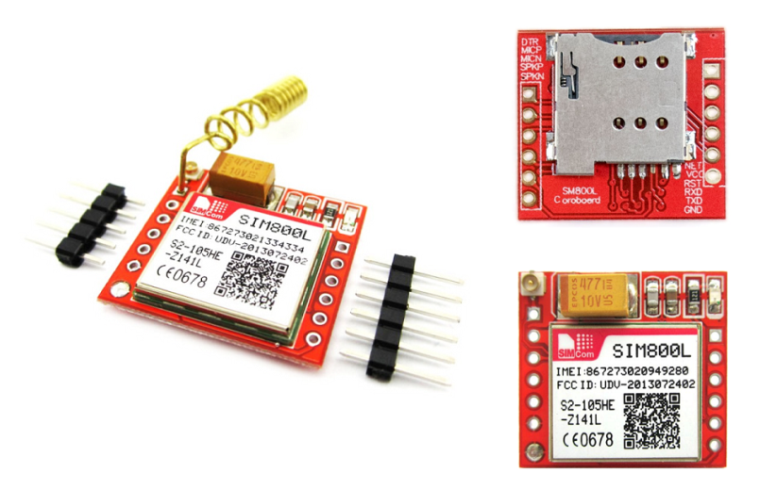

It requires a **SIM (Subscriber Identity Module)** card just like mobile phones to activate communication with the network. Also they have **IMEI** (International Mobile Equipment Identity) number similar to mobile phones for their identification. A GSM/GPRS MODEM can perform the following operations:

1.      Receive, send or delete SMS messages in a SIM.

2.      Read, add, search phonebook entries of the SIM.

3.      Make, Receive, or reject a voice call.

The MODEM needs **AT commands**, for interacting with processor or controller, which are communicated through serial communication. These commands are sent by the controller/processor. The MODEM sends back a result after it receives a command. Different AT commands supported by the MODEM can be sent by the processor/controller/computer to interact with the **GSM and GPRS cellular network**.

### **GSM Architecture**

The GSM architecture is divided into Radio Subsystem, Network and Switching Subsystem and the Operation Subsystem. The radio sub system consists of the Mobile Station and Base Station Subsystem.

The mobile station is generally the mobile phone which consists of a transceiver, display and a processor. Each handheld or portable mobile station consists of a unique identity stored in a module known as SIM (Subscriber Identity Chip). It is a small microchip which is inserted in the mobile phone and contains the database regarding the mobile station.

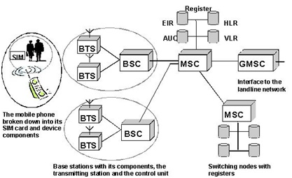

**NodeMCU:**

**Introduction to NodeMCU**

Node MCU is an open-source firmware and development kit that plays a vital role in designing your own IoT product using a few Lua script lines.

Multiple GPIO pins on the board allow you to connect the board with other peripherals and are capable of generating PWM, I2C, SPI, and UART serial communications.

* The interface of the module is mainly divided into two parts including both Firmware and Hardware where former runs on the ESP8266 Wi-Fi SoC and later is based on the ESP-12 module.

The firmware is based on Lua – A scripting language that is easy to learn, giving a simple programming environment layered with a fast scripting language that connects you with a well-known developer community.

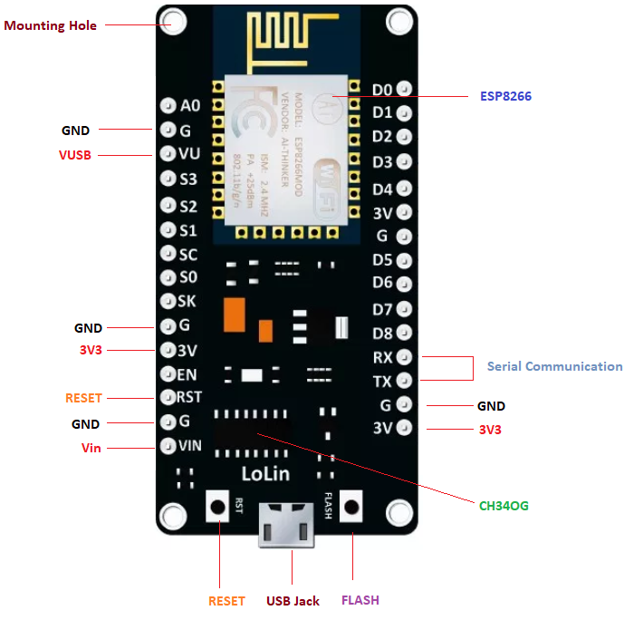

And open source firmware gives you the flexibility to edit, modify and rebuilt the existing module and keep changing the entire interface until you succeed in optimizing the module as per your requirements.

* USB to UART converter is added on the module that helps in converting USB data to UART data which mainly understands the language of serial communication.

Instead of the regular USB port, MicroUSB port is included in the module that connects it with the computer for dual purposes: programming and powering up the board.

* The board incorporates status LED that blinks and turns off immediately, giving you the current status of the module if it is running properly when connected with the computer.

The ability of module to establish a flawless WiFi connection between two channels makes it an ideal choice for incorporating it with other embedded devices like Raspberry Pi.

**NodeMCU Pinout:**

NodeMCU comes with a number of GPIO Pins. Following figure shows the Pinout of the board.

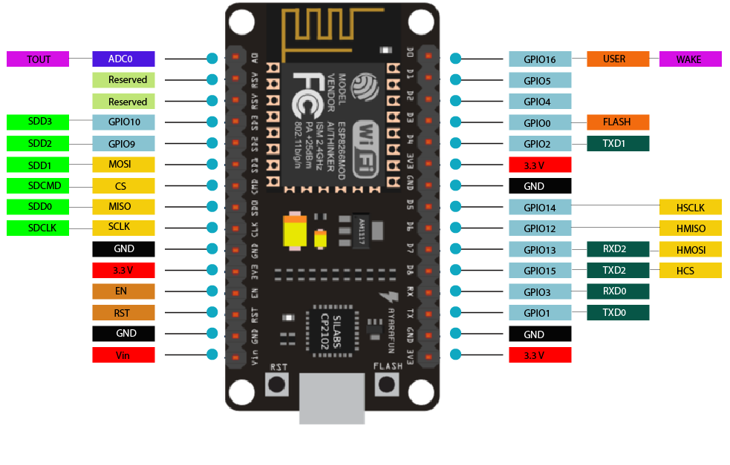

* There is a candid difference between VIN and VU where former is the regulated voltage that may stand somewhere between 7 to 12 V while later is the power voltage for USB that must be kept around 5 V.

**Features:**

* Open-source
* Arduino-like hardware
* Status LED
* MicroUSB port
* Reset/Flash buttons
* Interactive and Programmable
* Low cost
* ESP8266 with inbuilt wifi
* USB to UART converter
* GPIO pins

As mentioned above, a cable supporting micro USB port is used to connect the board. As you connect the board with a computer, LED will flash. You may need some drivers to be installed on your computer if it fails to detect the NodeMCU board. You can download the driver from [this](https://www.silabs.com/products/development-tools/software/usb-to-uart-bridge-vcp-drivers) page.

**Note:** We use [Arduino IDE](https://www.theengineeringprojects.com/2018/10/introduction-to-arduino-ide.html) software for programming this module. It is important to note that the pin configuration appearing on the board is different from the configuration we use to program the board on the software i.e. when we write code for targeting pin 16 on the Arduino IDE, it will actually help is laying out the communication with the D0 pin on the module.

Following figure the shows the pin configuration to use in Arduino IDE.

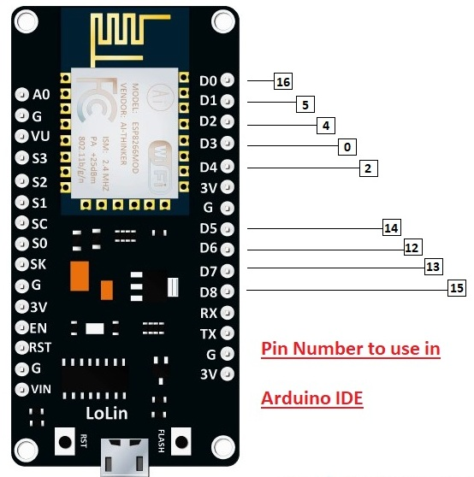

**How to Power NodeMCU**

You can see from the pinout image above, there are five ground pins and three 3V3 pins on the board. The board can be powered up using the following three ways.

**USB Power.**It proves to an ideal choice for loading programs unless the project you aim to design requires separate interface i.e. disconnected from the computer.

**Provide 3.3V.**This is another great option to power up the module. If you have your own off-board regulator, you can generate an instant power source for your development kit.

**Power Vin.** This is a voltage regulator that comes with the ability to support up to 800 mA. It can handle somewhere between 7 to 12 V. You cannot power the devices operating at 3.3 V, as this regulator unable to generate as low as 3.3V.

**Applications:**

NodeMCU V3 is mainly used in the WiFi Applications which most of the other embedded modules fail to process unless incorporated with some external WiFi protocol. Following are some major applications used for NodeMCU V3.

* Internet Smoked Alarm
* VR Tracker
* Octopod
* Serial Port Monitor
* ESP Lamp
* Incubator Controller
* IoT home automation
* Security Alarms

**Solar panel:**

**Photovoltaic solar panels** absorb [sunlight](https://en.wikipedia.org/wiki/Sunlight) as a source of energy to generate [electricity](https://en.wikipedia.org/wiki/Electricity). A [photovoltaic](https://en.wikipedia.org/wiki/Photovoltaic) (PV) module is a packaged, connected assembly of typically 6x10 photovoltaic [solar cells](https://en.wikipedia.org/wiki/Solar_cell). Photovoltaic modules constitute the photovoltaic array of a [photovoltaic system](https://en.wikipedia.org/wiki/Photovoltaic_system) that generates and supplies [solar electricity](https://en.wikipedia.org/wiki/Solar_electricity) in commercial and residential applications.

The most common application of solar energy collection outside agriculture is [solar water heating](https://en.wikipedia.org/wiki/Solar_water_heating) systems.

## Theory and construction

[Photovoltaic](https://en.wikipedia.org/wiki/Photovoltaic) modules use light energy ([photons](https://en.wikipedia.org/wiki/Photon)) from the Sun to generate electricity through the [photovoltaic effect](https://en.wikipedia.org/wiki/Photovoltaic_effect). The majority of modules use [wafer](https://en.wikipedia.org/wiki/Wafer_(electronics))-based [crystalline silicon](https://en.wikipedia.org/wiki/Crystalline_silicon) cells or [thin-film cells](https://en.wikipedia.org/wiki/Thin_film_solar_cell). The structural ([load carrying](https://en.wikipedia.org/wiki/Dead_and_live_loads)) member of a module can either be the top layer or the back layer. Cells must also be protected from mechanical damage and moisture. Most modules are rigid, but semi-flexible ones based on thin-film cells are also available. The cells must be connected electrically in series, one to another.

A PV [junction box](https://en.wikipedia.org/wiki/Junction_box) is attached to the back of the solar panel and it is its output interface. Externally, most of photovoltaic modules use [MC4 connectors](https://en.wikipedia.org/wiki/MC4_connector) type to facilitate easy weatherproof connections to the rest of the system. Also, USB power interface can be used.

Module electrical connections are made [in series](https://en.wikipedia.org/wiki/Series_circuits) to achieve a desired output voltage or [in parallel](https://en.wikipedia.org/wiki/Parallel_circuits) to provide a desired current capability (amperes). The conducting wires that take the current off the modules may contain silver, copper or other non-magnetic conductive transition metals. Bypass [diodes](https://en.wikipedia.org/wiki/Diode) may be incorporated or used externally, in case of partial module shading, to maximize the output of module sections still illuminated.

Some special solar PV modules include [concentrators](https://en.wikipedia.org/wiki/Solar_concentrator) in which light is focused by [lenses](https://en.wikipedia.org/wiki/Lens_(optics)) or mirrors onto smaller cells. This enables the use of cells with a high cost per unit area (such as [gallium arsenide](https://en.wikipedia.org/wiki/Gallium_arsenide)) in a cost-effective way.

Solar panels also use metal frames consisting of racking components, brackets, reflector shapes, and troughs to better support the panel structure.

**Technology:**

Most solar modules are currently produced from crystalline silicon (c-Si) [solar cells](https://en.wikipedia.org/wiki/Solar_cells) made of [multicrystalline](https://en.wikipedia.org/wiki/Polycrystalline_silicon) and [monocrystalline silicon](https://en.wikipedia.org/wiki/Monocrystalline_silicon). In 2013, crystalline silicon accounted for more than 90 percent of worldwide PV production, while the rest of the overall market is made up of [thin-film technologies](https://en.wikipedia.org/wiki/Thin_film_solar_cells) using [cadmium telluride](https://en.wikipedia.org/wiki/CdTe_PV), [CIGS](https://en.wikipedia.org/wiki/CIGS_panel) and [amorphous silicon](https://en.wikipedia.org/wiki/Amorphous_silicon)[[16]](https://en.wikipedia.org/wiki/Solar_panel#cite_note-16)

Emerging, [third generation](https://en.wikipedia.org/wiki/Thin_film_solar_cell#Emerging_photovoltaics) solar technologies use advanced thin-film cells. They produce a relatively high-efficiency conversion for the low cost compared to other solar technologies. Also, high-cost, high-efficiency, and close-packed rectangular [multi-junction (MJ) cells](https://en.wikipedia.org/wiki/Multi-junction_solar_cell) are preferably used in [solar panels on spacecraft](https://en.wikipedia.org/wiki/Solar_panels_on_spacecraft), as they offer the highest ratio of generated power per kilogram lifted into space. MJ-cells are [compound semiconductors](https://en.wikipedia.org/wiki/Compound_semiconductor) and made of [gallium arsenide](https://en.wikipedia.org/wiki/Gallium_arsenide) (GaAs) and other semiconductor materials. Another emerging PV technology using MJ-cells is [concentrator photovoltaics](https://en.wikipedia.org/wiki/Concentrator_photovoltaics) ( CPV ).

### Thin film

In rigid [thin-film modules](https://en.wikipedia.org/wiki/Thin-film_module), the cell and the module are manufactured in the same production line. The cell is created on a glass [substrate](https://en.wikipedia.org/wiki/Substrate_(materials_science)) or superstrate, and the electrical connections are created *in situ*, a so-called "monolithic integration". The substrate or superstrate is laminated with an encapsulant to a front or back [sheet](https://en.wiktionary.org/wiki/sheet), usually another sheet of glass. The main cell technologies in this category are [CdTe](https://en.wikipedia.org/wiki/Cadmium_telluride), or [a-Si](https://en.wikipedia.org/wiki/Amorphous_silicon), or [a-Si+uc-Si tandem](https://en.wikipedia.org/wiki/Micromorphous_silicon), or [CIGS](https://en.wikipedia.org/wiki/Copper_indium_gallium_selenide) (or variant). Amorphous silicon has a sunlight conversion rate of 6–12%

Flexible thin film cells and modules are created on the same production line by depositing the [photoactive layer](https://en.wikipedia.org/wiki/Photoactive_layer) and other necessary layers on a [flexible substrate](https://en.wikipedia.org/wiki/Flexible_substrate). If the substrate is an [insulator](https://en.wikipedia.org/wiki/Insulator_(electrical)) (e.g. [polyester](https://en.wikipedia.org/wiki/Polyester) or [polyimide](https://en.wikipedia.org/wiki/Polyimide) film) then [monolithic](https://en.wikipedia.org/wiki/Die_(integrated_circuit)) integration can be used. If it is a conductor then another technique for electrical connection must be used. The cells are assembled into modules by [laminating](https://en.wikipedia.org/wiki/Laminating) them to a transparent colourless [fluoropolymer](https://en.wikipedia.org/wiki/Fluoropolymer) on the front side (typically [ETFE](https://en.wikipedia.org/wiki/ETFE) or [FEP](https://en.wikipedia.org/wiki/Fluorinated_ethylene_propylene)) and a polymer suitable for bonding to the final substrate on the other side.

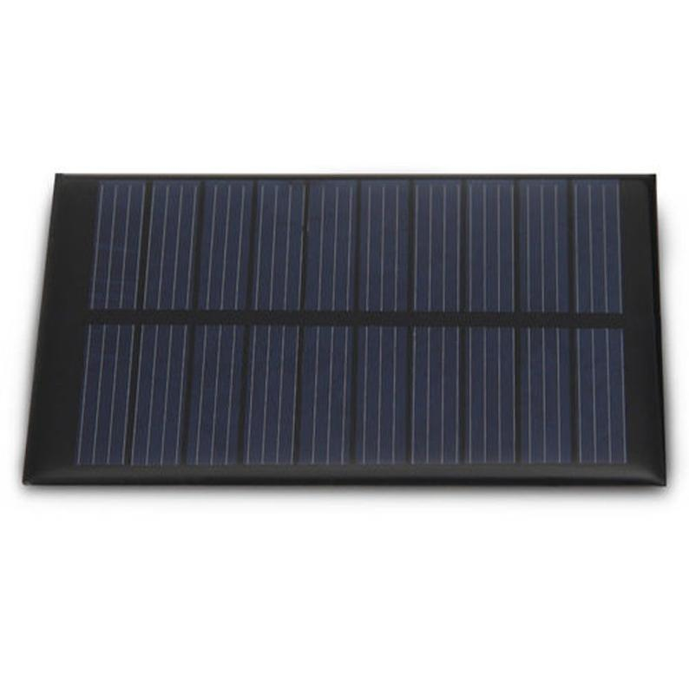

**Battery:**

A rechargeable battery is an energy storage device that can be charged again after being discharged by applying [DC](https://whatis.techtarget.com/definition/DC-direct-current) current to its terminals.

Rechargeable [batteries](https://searchmobilecomputing.techtarget.com/definition/battery) allow for multiple usages from a cell, reducing waste and generally providing a better long-term investment in terms of dollars spent for usable device time. This is true even factoring in the higher purchase price of rechargeable and the requirement for a charger.  
A rechargeable battery is generally a more sensible and sustainable replacement to one-time use batteries, which generate current through a chemical reaction in which a reactive anode is consumed. The anode in a rechargeable battery gets consumed as well but at a slower rate, allowing for many charges and discharges.

In use, rechargeable batteries are the same as conventional ones. However, after discharge the batteries are placed in a charger or, in the case of built-in batteries, an [AC](https://whatis.techtarget.com/definition/alternating-current-AC)/DC adapter is connected.

While rechargeable batteries offer better long term cost and reduce waste, they do have a few cons. Many types of rechargeable cells created for consumer devices, including AA and AAA, C and D batteries, produce a lower voltage of 1.2v in contrast to the 1.5v of alkaline batteries. Though this lower voltage doesn't prevent correct operation in properly-designed electronics, it can mean a single charge does not last as long or offer the same power in a session. This is not the case, however, with lithium polymer and [lithium ion batteries](https://searchmobilecomputing.techtarget.com/definition/Lithium-Ion-battery).

Some types of batteries such as [nickel cadmium](https://searchmobilecomputing.techtarget.com/definition/Nickel-Cadmium-battery) and [nickel-metal hydride](https://searchmobilecomputing.techtarget.com/definition/Nickel-Metal-Hydride-battery) can develop a [battery memory effect](https://whatis.techtarget.com/definition/battery-memory-effect) when only partially discharged, reducing performance of subsequent charges and thus [battery life](https://whatis.techtarget.com/definition/battery-life) in a given device.

Rechargeable batteries are used in many applications such as cars, all manner of consumer electronics and even off-grid and supplemental facility power storage.

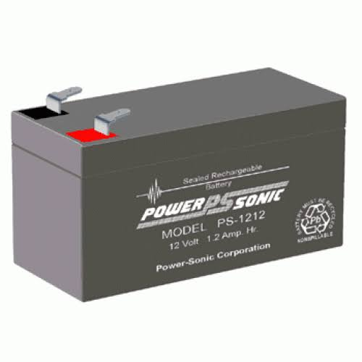

**EMBEDDED C**

Implanted C makes use of KEIL IDE programming. The framework program written in implanted C can be placed away in Microcontroller. The accompanying is a portion of the actual motives behind composing applications in C as opposed to get collectively. It is much less disturbing and much less tedious to write down in C then amassing. C is less traumatic to trade and refresh. You can utilize code available in capacity libraries. C code is compact to different microcontrollers with subsequent to 0 alteration. Genuine, installed C programming need nonstandard expansions to the C driver with a view to bolster charming components, as an example, settled point range catching, numerous unmistakable reminiscence banks, and fundamental I/O operations.

In 2008, the C Standards Committee prolonged the C data to deal with these problems via giving a normal well known to all executions to purchaser to contains numerous additives not handy in standard C, for example, settled factor wide variety catching, named address spaces, and vital I/O equipment tending to.

Installed C utilize the greater part of the grammar and semantics of wellknown C, e.G., number one() paintings, variable definition, facts type statement, contingent proclamations (if, switch. Case), circles (even as, for), capacities, exhibits and strings, structures and union, piece operations, macros, unions, and so on.

**Embedded systems programming**

Installed frameworks writing computer programs is not quite the same as creating applications on a desktop PCs. Key attributes of an implanted framework, when contrasted with PCs, are as per the following:

•Embedded gadgets have asset limitations (restricted ROM, constrained RAM, constrained stack space, less handling power)

•Components utilized as a part of installed framework and PCs are distinctive; implanted frameworks ordinarily utilizes littler, less power devouring segments. Inserted frameworks are more fixing to the equipment.

Two remarkable components of Embedded Programming are code speed and code estimate. Code speed is represented by the handling power, timing requirements, while code size is administered by accessible program memory and utilization of programming dialect. Objective of implanted framework writing computer programs is to get greatest elements in least space and least time.

Implanted frameworks are modified utilizing distinctive sort of dialects:

•Machine Code

•Low level dialect, i.e., get together

•High level dialect like C, C++, and Java and so on.

•Application level dialect like Visual Basic, scripts, Access, and so on..,

**Arduino IDE:**

The Arduino IDE software is a open source software, where we can have the example codes for the beginners. In the Present world there are lot of version in the Arduino IDE in which present usage is Version1.0.5. It is very easy to connect the PC with Arduino Board.

First we have to install the Arduino IDE software according to the below instructions:

* Insert the CD-ROM or PENDRIVE which Contains the software and then Copy the Setup File to your desired location.
* After Copying, now click on the setup you will see an window shown below
* 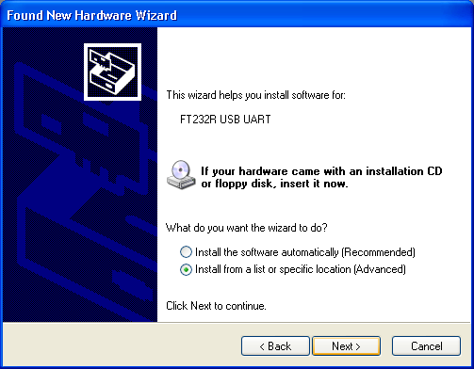Click On NO, not this time. Then after NEXT
* 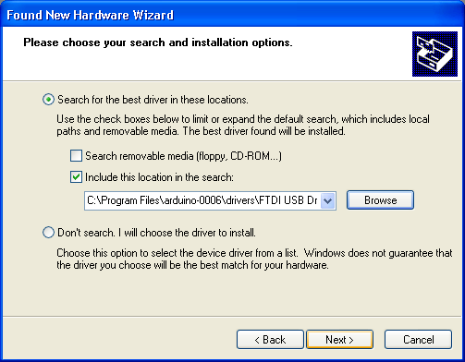Another Window opens –select Install from a list of specific location and NEXT
* Select “include this location in the search” and then click Browse option available in it
* Now it will Automatically check the USB driver and the software is installed click Finish

.

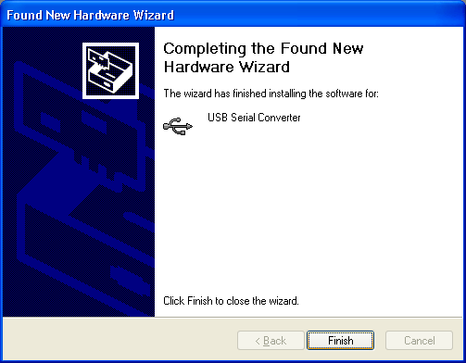

* Now click Finish, the Software will be downloaded.
* Now click on the Arduino IDE icon present on your Desktop. A window will appear like this.

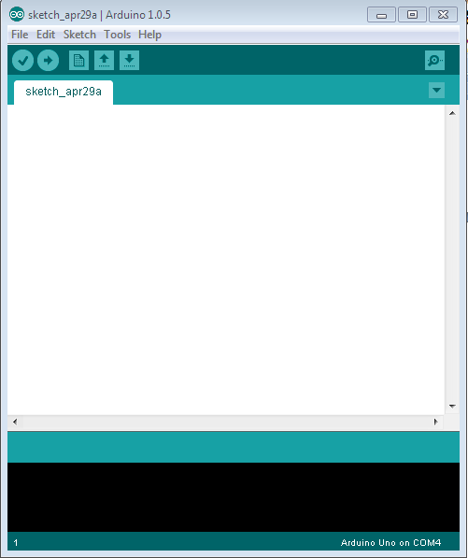

* For any sample programs, select FILE option🡪Examples.

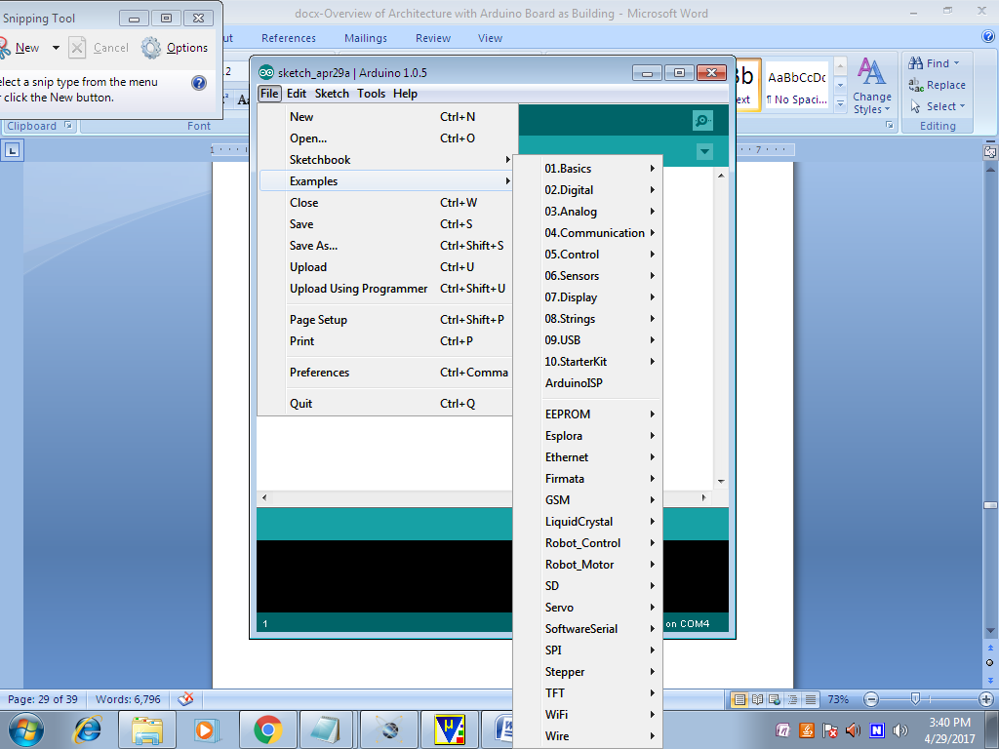

* After Entering the Sample Code in the file, it would look like this

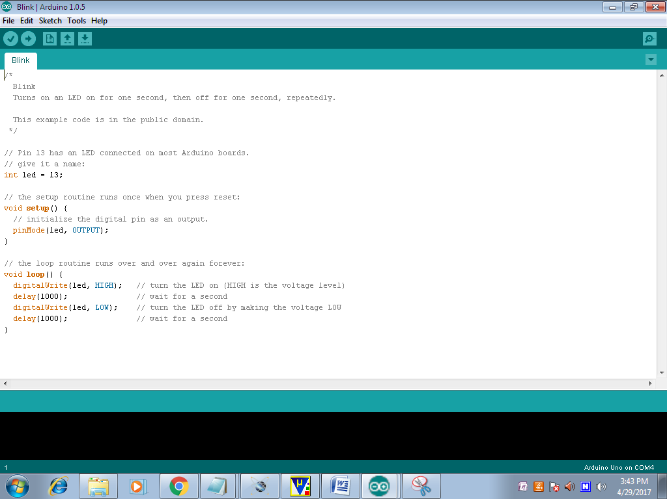

* Before Connecting we have to select which Board is used by the user, Basically UNO. By selecting TOOLS🡪Board🡪ARDUINO UNO

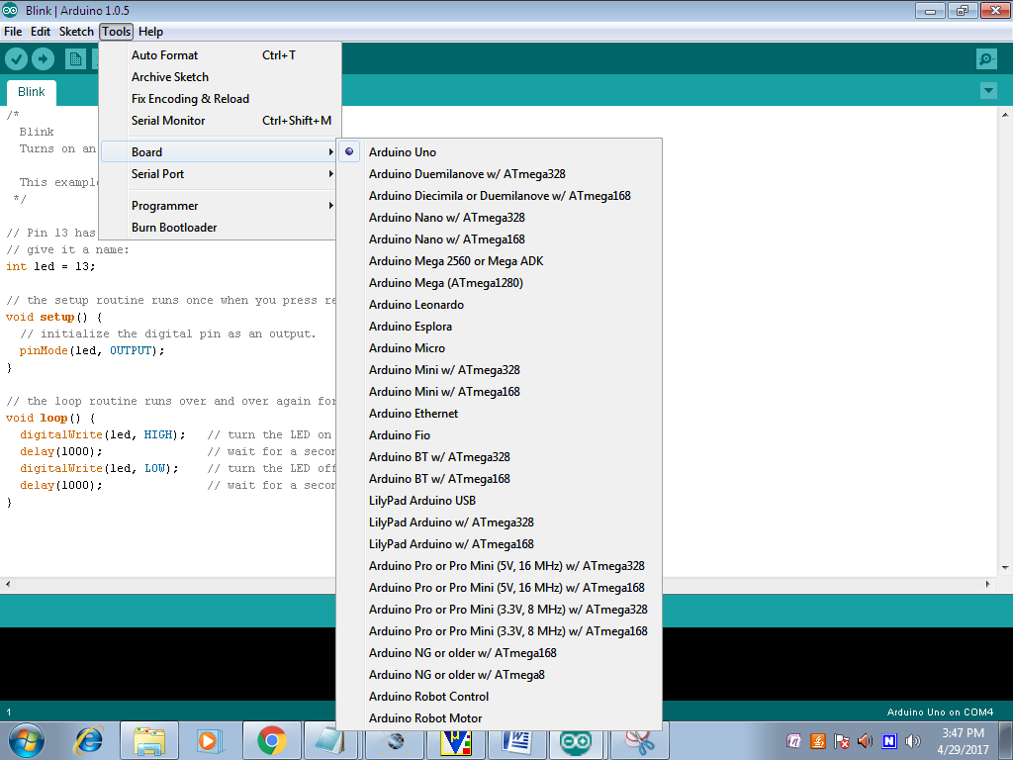

* Now to dump the in the board Connect the Arduino to the PC through the USB port available in it. Like this TOOLS🡪SERIAL PORT🡪COMM4,COMM8 etc;

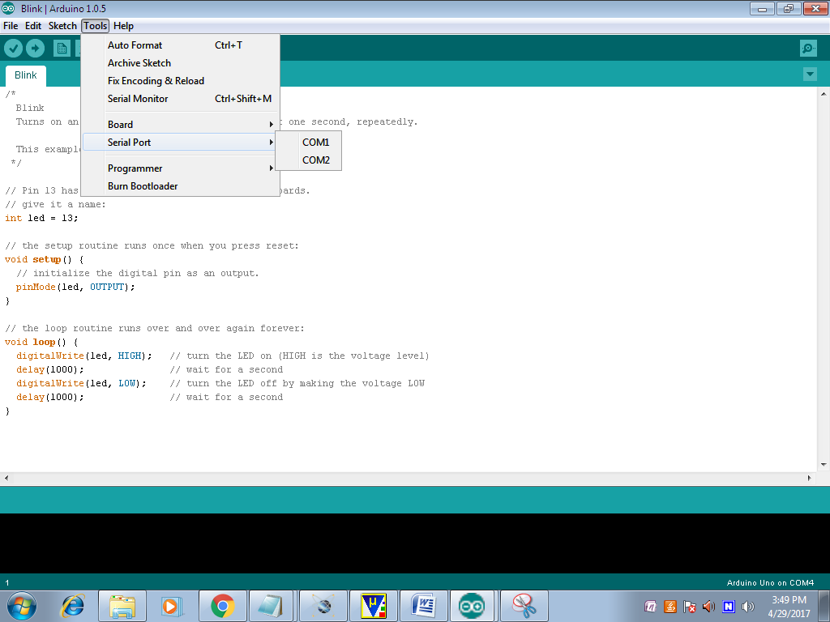

* To verify the written Program select COMPILE option available in the software ($√$).
* Now Connect the Board and select the COMM port and then UPLOAD the file in ARDUINO(🡪)
* To OPEN the Previous ARDUINO FILE selects $(↑)$ option.
* To enter new files select NEW option.
* To Save the Existing File, Click on the $(↓)$.
* To Send the Data Through Serial Monitor, Click on the (Ǫ).

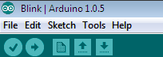

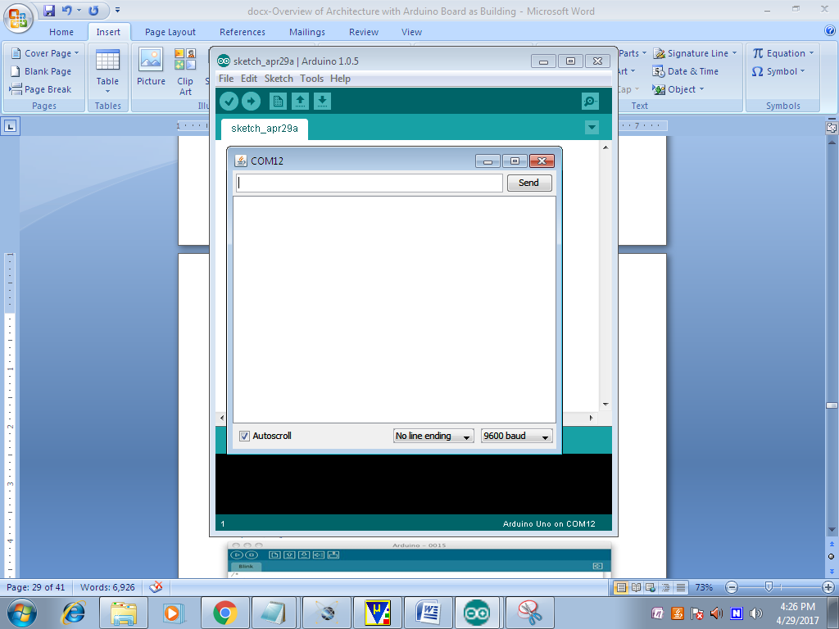

* Here we can see the Serial Data.

**PYTHON:**



Python is a general purpose, dynamic, high level and interpreted programming language. It supports Object Oriented programming approach to develop applications. It is simple and easy to learn and provides lots of high-level data structures. It is easy to learn yet powerful and versatile scripting language which makes it attractive for Application Development. It's syntax and dynamic typing with its interpreted nature, makes it an ideal language for scripting and rapid application development. It supports multiple programming patterns, including object oriented, imperative and functional or procedural programming styles. It is not intended to work on special area such as web programming. That is why it is known as multipurpose because it can be used with web, enterprise, 3D CAD etc. We don't need to use data types to declare variable because it is dynamically typed so we can write a=10 to assign an integer value in an integer variable.It makes the development and debugging fast because there is no compilation step included in python development and edit-test-debug cycle is very fast.

**Python Features**

Python provides lots of features that are listed below.

1) Easy to Learn and Use

Python is easy to learn and use. It is developer-friendly and high level programming language.

2) Expressive Language

Python language is more expressive means that it is more understandable and readable.

3) Interpreted Language

Python is an interpreted language i.e. interpreter executes the code line by line at a time. This makes debugging easy and thus suitable for beginners.

4) Cross-platform Language

Python can run equally on different platforms such as Windows, Linux, Unix and Macintosh etc. So, we can say that Python is a portable language.

5) Free and Open Source

Python language is freely available at address. The source-code is also available. Therefore it is open source.

6) Object-Oriented Language

Python supports object oriented language and concepts of classes and objects come into existence.

7) Extensible

It implies that other languages such as C/C++ can be used to compile the code and thus it can be used further in our python code.

8) Large Standard Library

Python has a large and broad library and provides rich set of module and functions for rapid application development.

9) GUI Programming Support

Graphical user interfaces can be developed using Python.

10) Integrated

It can be easily integrated with languages like C, C++, JAVA etc.

**Python History**

* Python laid its foundation in the late 1980s.
* The implementation of Python was started in the December 1989 by **Guido Van Rossum** at CWI in Netherland.
* In February 1991, van Rossum published the code (labeled version 0.9.0) to alt.sources.
* In 1994, Python 1.0 was released with new features like: lambda, map, filter, and reduce.
* Python 2.0 added new features like: list comprehensions, garbage collection system.
* On December 3, 2008, Python 3.0 (also called "Py3K") was released. It was designed to rectify fundamental flaw of the language.
* *ABC programming language* is said to be the predecessor of Python language which was capable of Exception Handling and interfacing with Amoeba Operating System.
* Python is influenced by following programming languages:
  + ABC language.
  + Modula-3

**Python Version**

Python programming language is being updated regularly with new features and supports. There are lots of updations in python versions, started from 1994 to current release.

A list of python versions with its released date is given below.

Python Version Released Date

Python 1.0 January 1994

Python 1.5 December 31, 1997

Python 1.6 September 5, 2000

Python 2.0 October 16, 2000

Python 2.1 April 17, 2001

Python 2.2 December 21, 2001

Python 2.3 July 29, 2003

Python 2.4 November 30, 2004

Python 2.5 September 19, 2006

Python 2.6 October 1, 2008

Python 2.7 July 3, 2010

Python 3.0 December 3, 2008

Python 3.1 June 27, 2009

Python 3.2 February 20, 2011

Python 3.3 September 29, 2012

Python 3.4 March 16, 2014

Python 3.5 September 13, 2015

Python 3.6 December 23, 2016

Python 3.6.4 December 19, 2017

**Python Applications Area**

Python is known for its general purpose nature that makes it applicable in almost each domain of software development. Python as a whole can be used in any sphere of development.

Here, we are specifying applications areas where python can be applied.

1) Web Applications

We can use Python to develop web applications. It provides libraries to handle internet protocols such as HTML and XML, JSON, Email processing, request, beautifulSoup, Feedparser etc. It also provides Frameworks such as Django, Pyramid, Flask etc to design and delelop web based applications. Some important developments are: PythonWikiEngines, Pocoo, PythonBlogSoftware etc.

2) Desktop GUI Applications

Python provides Tk GUI library to develop user interface in python based application. Some other useful toolkits wxWidgets, Kivy, pyqt that are useable on several platforms. The Kivy is popular for writing multitouch applications.

3) Software Development

Python is helpful for software development process. It works as a support language and can be used for build control and management, testing etc.

4) Scientific and Numeric

Python is popular and widely used in scientific and numeric computing. Some useful library and package are SciPy, Pandas, IPython etc. SciPy is group of packages of engineering, science and mathematics.

5) Business Applications

Python is used to build Bussiness applications like ERP and e-commerce systems. Tryton is a high level application platform.

6) Console Based Application

We can use Python to develop console based applications. For example: **IPython**.

7) Audio or Video based Applications

Python is awesome to perform multiple tasks and can be used to develop multimedia applications. Some of real applications are: TimPlayer, cplay etc.

8) 3D CAD Applications

To create CAD application Fandango is a real application which provides full features of CAD.

9) Enterprise Applications

Python can be used to create applications which can be used within an Enterprise or an Organization. Some real time applications are: OpenErp, Tryton, Picalo etc.

10) Applications for Images

Using Python several application can be developed for image. Applications developed are: VPython, Gogh, imgSeek etc. There are several such applications which can be developed using Python.

**Advantages:**

* Automation
* Efficiency
* Sustainability
* Remote-monitoring
* Real-time

**Applications:**

* Agriculture
* Horticulture
* Landscaping
* Greenhouses
* Farming

**Conclusion:**

The automatic irrigation system effectively integrates soil moisture and water level sensors with real-time monitoring through the Node MCU and Adafruit IoT platform. By incorporating GSM alerts, a buzzer for abnormal conditions, and an LCD for local display, the system ensures timely and efficient water management. The use of solar power enhances sustainability, while the DC pump automates irrigation based on sensor feedback, promoting optimal crop growth and resource conservation. Overall, this smart system offers a reliable, energy-efficient, and remote-controlled solution for modern agricultural needs.

**References:**

[1] A. Klute, *Methods of Soil Analysis, Part 1: Physical and Mineralogical Methods*, Madison, WI, USA: American Society of Agronomy, 1986, pp. 1–1188.

[2] J. H. Knight, “Sensitivity of time domain reflectometry measurements to lateral variations in soil water content,” *Water Resources Research*, vol. 28, pp. 2345–2352, 1992.

[3] R. D. Magagi and Y. H. Kerr, “Retrieval of soil moisture and vegetation characteristics by use of ERS-1 wind scatterometer over arid and semi-arid areas,” *J. Hydrology*, vol. 188–189, pp. 361–384, 1997.

[4] H. P. Marthaler, W. Vogelsanger, F. Richard, and J. P. Wierenga, “A pressure transducer for field tensiometers,” *Soil Sci. Soc. Am. J.*, vol. 47, pp. 624–627, 1983.

[5] E. Attema et al., “Sentinel-1 - the radar mission for GMES operational land and sea services,” *ESA Bulletin*, vol. 131, pp. 10–17, 2007.